Melinda’s Story
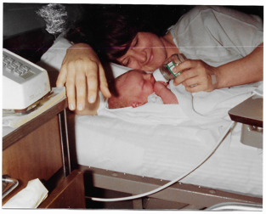
In April 1981, when all should have been joy and excitement with the arrival of my first child, Patrick, things took a sideways turn during his delivery. Without going into graphic detail, I ended up having to have two units of blood transfused right after delivery. My health and welfare were in jeopardy, and to say I was terrified was an understatement. But, thanks to the generosity of people I didn’t even know, there was blood available to meet my needs, and restore my health so that I might enjoy the excitement and joy of being a new mom. I am, to this day, still so very grateful for those who selflessly donate the gift of life so that others might live. As a result of this experience, it led me to become a lifelong blood donor. I even took it a step further by offering my Aggie students extra credit for donating blood, or at least trying! My advice to others……if you are able to donate, please do……every drop makes a difference!
Melinda Grant

